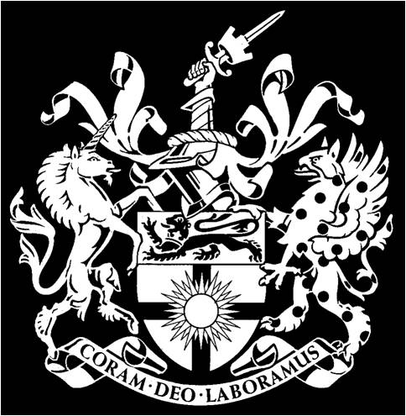 | CITY & GUILDS COLLEGE ASSOCIATION LIMITED  ANNUAL GENERAL MEETING 2020  Minutes  Meeting held on ZOOM, starting at 17:30, on 8th June 2020
Version | V1.0, dated 7th June 2021
The President, Professor Richard Kitney opened the meeting, which was attended by 45 members. Six apologies were received.
http://www.cgca.org.uk

1 | Minutes of AGM held on 10th June 2019  The minutes of this meeting were approved.
2 | President’s Review  The President presented a review of the last year’s activities, and in particular the last 3 months under COVID restrictions.  The Annual Dinner was held just before lockdown and was a great success. The guest speaker was Captain David Henson MBE and the response for the guests was given by Prof Anil Bharath. The Dinner was attended by many students and younger members. Richard thanked Colin Kerr and the Imperial Alumni team for the organisation of the event.  The saga of the Honour Shields continues, While recreating the missing shields continues, there are still discussions about where the shields will be displayed in College.  Both issues of IE were excellent, with key information and articles, and he thanked Peter and Allison Buck for their work.  The OC Trust had a very successful year up until the start of lockdown and Richard thanked Chris Lumb for his work as Chair of the Trust.  In closing, Richard talked of how much he had enjoyed his (unexpected) 3 years as President and wished the Association every success in the coming years.
3 | 2019 Accounts and Balance Sheet  Hon Treasurer, Peter Chase, presented the accounts. The Association continues on a sound financial footing. The accounts were approved by the meeting.
4 | Inauguration of President 20/21, 21/22  Richard welcomed Professor Atula Abeysekera and (virtually) handed over the Presidency. Atula accepted the Presidency and thanked Richard for his work over the past 3 years.  Atula chaired the meeting from this point on.
5 | Election of Officers and Committee Members
5a | Professor Anil Bharath was elected as Senior Vice President.
5b | Nigel Cresswell was elected as Hon Sec, and Peter Chase was elected as Hon Treas.
5c | The following people were elected to officer posts as follows:  Dep Hon Treas: Andrew Hill  Dep Hon Sec: Milia Hasbani  Younger Members Secretary: Tim Munday.  Annual Dinner Event Manager: Colin Kerr.  Decade Reunion Event Manager: Peter Chase.  Managing Editor IE: Peter Buck.  Events Coordinator: Charles Parry.  Departmental Representatives:  Aero Engineering: Daniel Johnpillia  Bioengineering: Haroon Chughtai  Chemical Engineering: Judith Hackitt and Peter Lynch  Civil & Environmental Engineering: Atula Abeysekera and Colin Kerr  Computing: James Prince, Alessandro Bonardi  Design Engineering: Vacancy  Electrical & Electronic Engineering: Christopher Baker-Brian and Andrei Pogan  Mechanical Engineering: Charles Parry and Owen Heaney.
6 | ACGI Departments  A list of departments in which ACGI is awarded was read and recorded.
7 | Any Other Business  Atula expressed his determination on keeping CGCA functioning through the COVID restrictions and commented it was a good sign that this virtual AGM was the best attended for some years!
The meeting was closed at 18:00

Nigel Cresswell, Hon Sec CGCA May 2021

