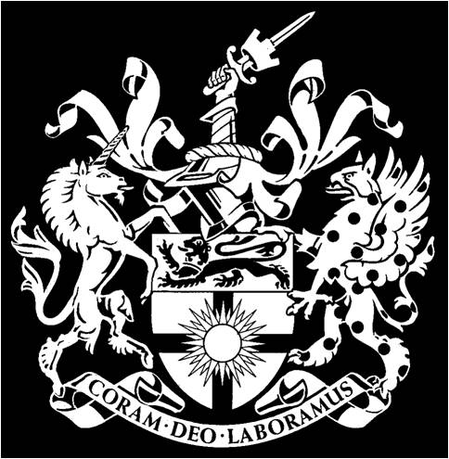 | CITY & GUILDS COLLEGE ASSOCIATION LIMITED  ANNUAL GENERAL MEETING 2019  Minutes  Meeting held in the Council Rooms, 170 Queens Gate, Imperial College South Kensington Campus, starting at 17:30, on 10th June 2019
Version | V1.0, dated 14th May 2020
The President, Professor Richard Kitney chaired the meeting, which was attended by 33 members. Seven apologies were received.
http://www.cgca.org.uk

1 | Minutes of AGM held on 17th June 2018  The minutes of this meeting were approved and were signed as a true record.
2 | President’s Review  The President presented a review of the last year’s activities.  Richard thanked Peter Chase, Nigel Cresswell and other committee members for their support.  CGCA activity with CGCU had included a number of Departmental level career guidance evenings. Replacing the lost Honour Shields and making the ones never commissioned is continued to be an issue. While making the shields was in hand, where to display them remained the subject of discussions with College.  He thanked Eilidh and Nicola from the Alumni Relations team for their support.  Transforming CGCA to a Company Limited by Guarentee had been the major effort. This was successfully completed on the stroke of midnight 31st December. The President thanked Roger Venables for his invaluable support and efforts through the process.  Both issues of IE were excellent, with key information and articles, and he thanked Peter and Allison Buck for their work.  The Annual Dinner in February was a great success with 125 attendees, including many students. The President thanked Colin Kerr and Alumni Relations for their work on the Dinner.  The 5 & 10 year reunion, held at the Polish Club was a great success and the President thanked Peter Chase for organising the lunch.  The OC Trust had a very successful year distributing £55K to 180 students, as well as making many student awards for non-academic activities.  In a brief look to the future Richard identified alumni/student events at Departmental level, increasing student membership and working with the Faculty as priorities.
3 | 2018 Accounts and Balance Sheet  Hon Treasurer, Peter Chase, presented the accounts. Investments had dipped mid-year but have since recovered. In general, events did well during the year requiring less in subsidies. The accounts were approved by the meeting.
4 | Appointment of Auditors  Peter Chase proposed Messrs Cooper Gibson & Co be appointed as auditors until the next AGM in 2020. This was approved by the meeting.
5 | Election of Officers and Committee Members
5a | Nigel Cresswell was elected as Hon Sec, and Peter Chase was elected as Hon Treas.
5b | The following people were elected to the other officer posts as follows:  Dep Hon Treas: Andrew Hill  Dep Hon Sec: Milia Hasbani  Younger Members Secretary: Tim Munday.  Annual Dinner Event Manager: Colin Kerr.  Decade Reunion Event Manager: Peter Chase.  Managing Editor IE: Peter Buck.  Events Coordinator: Charles Parry.  Departmental Representatives:  Aero Engineering: Tim Munday  Bioengineering: vacancy  Chemical Engineering: Judith Hackitt and Peter Lynch  Civil & Environmental Engineering: Atula Abeysekera and Colin Kerr  Computing: vacancy  Design Engineering: Vacancy  Electrical & Electronic Engineering: Christopher Baker-Brian and Andrei Pogan  Mechanical Engineering: Charles Parry and Owen Heaney.
6 | ACGI Departments  A list of departments in which ACGI is awarded was read and recorded.
7 | Any Other Business  The President commented that it was good see more younger members joining the committee and hoped that during the year we could address the attraction of the Association to younger/students members.
The meeting was closed at 18:00

Nigel Cresswell, Hon Sec CGCA May 2020

